12. Stretch goal — a phone app on the same backend
The ask: an app that talks to the same system, so members can register for games and manage their accounts easily.
The headline is that this needs nothing new from the data model. Because permissions are enforced by row-level security inside Postgres rather than by whichever screen happens to be rendering, a second client cannot quietly become a second security model. The app signs in as the same member, carries the same token, and the same policies decide what comes back. That is the return on the decision in section 10 — it looked like extra work for the web app and it is what makes the app nearly free.

Diagram 7 — one backend, three clients
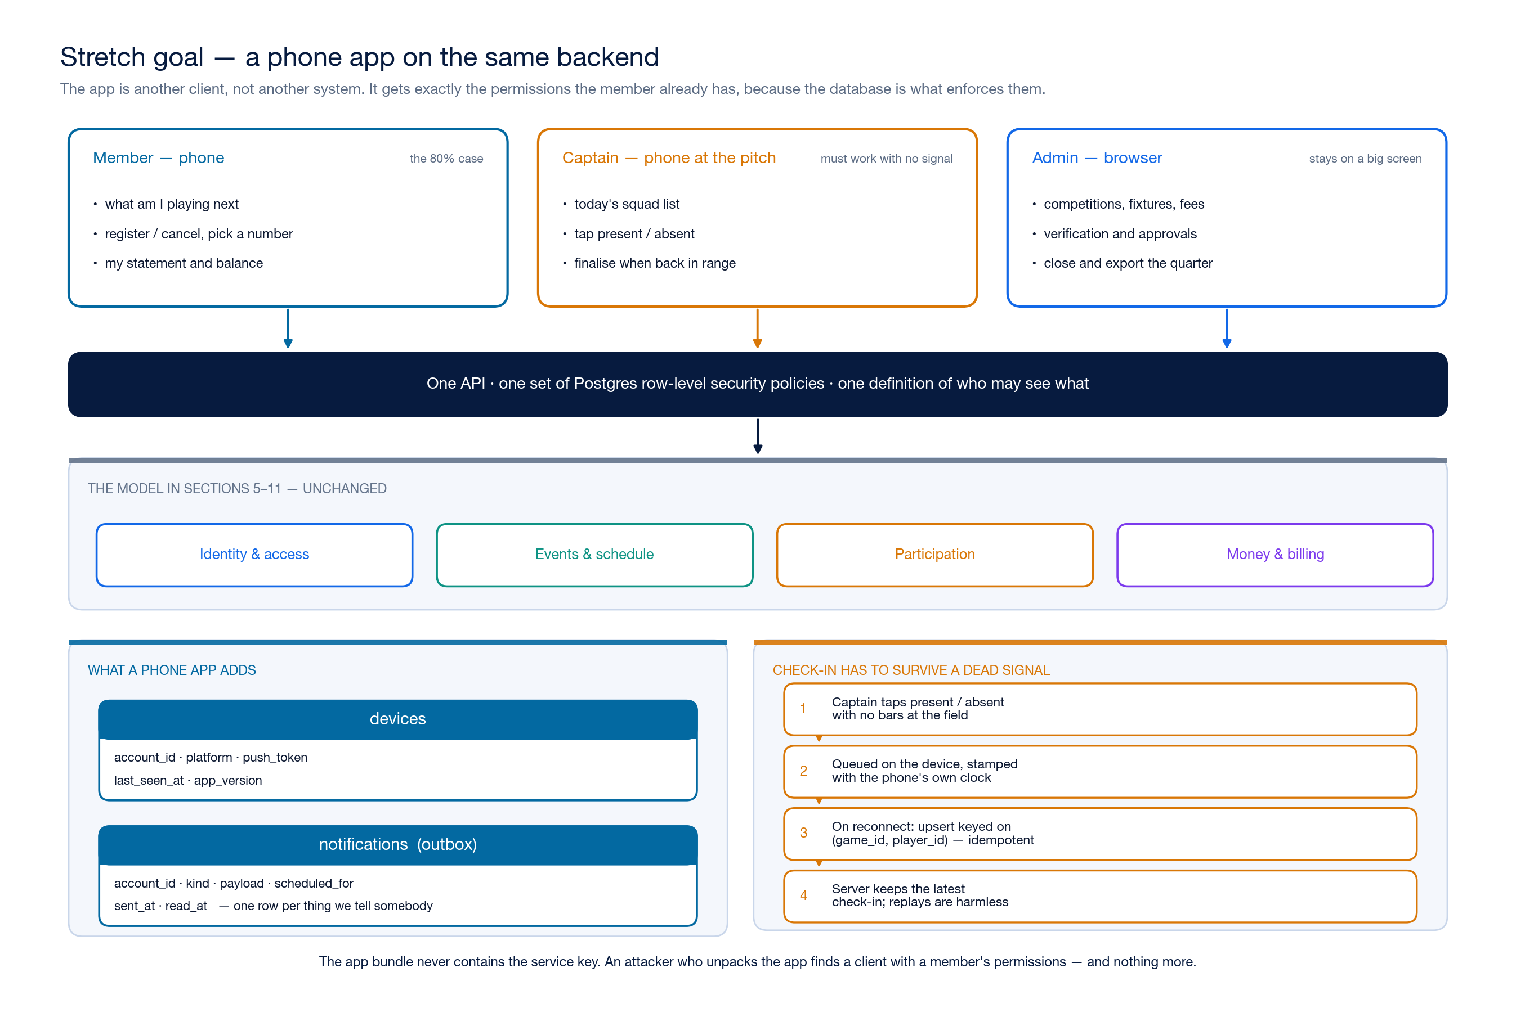
Member phone, captain phone, admin browser — one API and one set of policies. Full resolution: docs/design/diagrams/07-clients.png

What is actually worth building, in cost order
1. Mobile-first web — free. Build milestones 1–4 responsively and the phone case is already handled. This is not a compromise: check-in is only ever done on a phone, standing on grass, so that screen should be designed for a thumb from the first commit rather than retrofitted.
2. A PWA — small. A web app manifest and a service worker turn the same site into something installable on a home screen, with an offline shell and web push. iOS has supported push for installed web apps since 16.4. No app store, no review cycle, no second codebase, and members get an icon on their phone.
3. Native, React Native or Expo — a real cost. Worth it only when you need push you can absolutely rely on, an App Store listing people search for, or native camera and wallet integration. It is a second codebase and a release process forever.
My recommendation is that 1 and 2 are the plan, and 3 stays a decision you make later, once members are actually using the thing and can tell you whether the home-screen icon is enough. Going straight to native is the most common way a volunteer-run club ends up with a half-finished app and a website nobody updated.

What it adds to the schema
Two tables, and both are wanted for email reminders whether or not an app ever ships:
Table | Purpose
devices | account_id, platform, push token, last_seen_at, app version. One row per installed device, so a member with a phone and a tablet gets both.
notifications | An outbox: recipient, kind, payload, scheduled_for, sent_at, read_at. One row per thing we tell somebody, which makes "did the reminder actually go out?" a query rather than a guess.
The obvious notifications to start with: registration confirmed, promoted off the waitlist, a reminder the evening before with the gather time and pitch, and the quarterly statement.

Offline check-in, which is the one genuinely hard part
Fields have no signal. A captain marking twenty people present cannot depend on a network round-trip per tap, and must not lose the lot when they walk into a dead spot.
The approach: the device queues each mark locally with its own timestamp, and syncs when it reconnects. Two properties make this safe, and both come from decisions already in the schema:
- game_registrations already has unique (game_id, player_id), so a sync is an upsert on a natural key, not an insert that might duplicate. Replaying the same queue twice changes nothing.
- Attendance is a state, not an event — present, absent, excused. Last write wins on checked_in_at is a correct and comprehensible rule, and no count is derived from a sequence of deltas that could arrive out of order.
The client sends the phone's clock in checked_in_at; the server keeps the latest per row. A captain's phone that has been offline for an hour cannot overwrite a correction an admin made five minutes ago, so the sync compares timestamps rather than blindly taking the client's word.

Two things not to get wrong
The service key never goes in the app bundle. An app binary is fully inspectable — anyone can unpack it. The app authenticates as the member and gets the member's permissions; anything needing more runs server-side. This is the same rule as the web app, but the consequences of breaking it are worse because you cannot revoke a shipped binary.
Sign-in has to survive the app store. Magic links need deep-link handling so tapping the email opens the app rather than a browser tab that knows nothing. Budget for it — it is the single most common place a club app frustrates people on day one.

